Children ages 4-12 years old (younger children are welcome with a parent)

are invited to join us for a free Vacation Bible Camp!

**Dates: July 29th-31st 9:00 am-11:30 am**

**Where:** Good Shepherd By The Lake Lutheran Church

1860 US HWY 51 (3 miles north of Stoughton)

**SCAN BELOW TO REGISTER** or contact the church office at (608) 873-5924 or email: [gsoffice@tds.net](mailto:gsoffice@tds.net)

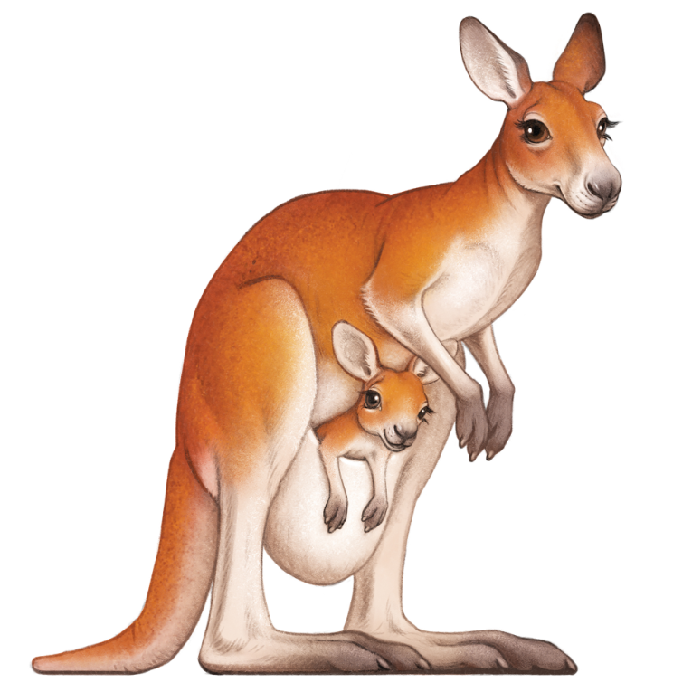

**Kids will enjoy:**

Christian education about God’s love for all,

Bible lessons, crafts, music, outdoor

activities and snacks.